**A Ray of Sunshine in the Life of Khloé Kardashian**



At least there is now something to smile about in the tumultuous life of Khloé Alexandra Kardashian; a bouncing baby girl! For most Americans and for many people across the globe, the Kardashians of the reality television series, *Keeping Up with the Kardashians* are household names. The series has won several television awards and nominations. Khloé is the third in a family of four siblings. She has two older sisters, Kourtney and Kim and a younger brother, Rob.



Together they star with their half-sisters Kendall and Kylie Jenner and parents, Kris and Caitlyn Jenner in the blockbuster realty show. Khloé Kardashian’s career transcends the family realty show. She is a star in her own rights and has played leading roles such as Dannii Hillman in *Psychotherapist* (2010). She has successfully hosted her own talk show, *Kocktails with Khloé.* She is also a businesswoman, model and socialite.



Khloé shared the first video clip of her first child on Instagram. The baby girl who was born exactly one month ago on the 12th of April 2018. The arrival of the baby brings a ray of sunshine into her romantic but rocky relationship with basketball player Tristan Thompson who has been accused of cheating on Khloe Kardashian with other girls.

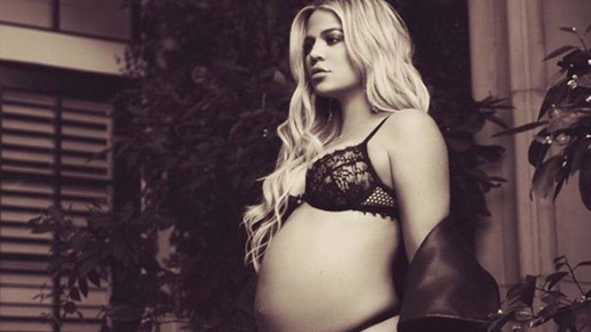

Khloe lives with Tristan in Cleveland, Ohio and although rumours had been awash since September 2017 of Khloe being pregnant and carrying his baby, it was only in December 2017, a few months to delivery, that she confirmed they were expecting their first child together. A few days after the birth, Khloe announced on the 16th of April in her post on Instagram that the baby has been named True Thompson.



Apparently she has been named True after one of Khloe’s grandfathers. Part of her post on Instagram reads as follows "Our little girl, True Thompson, has completely stolen our hearts and we are overwhelmed with LOVE. Such a blessing to welcome this angel into the family! Mommy and Daddy loooooove you True!"

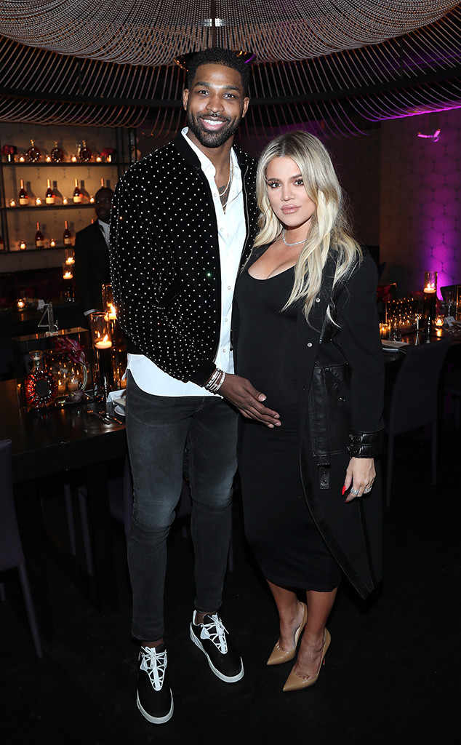

**Khloe and Tristan**

The arrival of baby True must be a welcome relief for both parents because the scandal could have resulted in breaking up the relationship. Reliable sources in the news media have revealed that Khloe is giving Tristan "another chance". According to the report "Khloe has given Tristan another chance at their relationship, and is trying to put the pieces back together for the sake of True. Although she is crushed by the scandal, Khloe desperately wants things to work and wants to have a complete family."

Khloe is no stranger to failed romantic relationships. Her marriage a decade ago in September 27, 2009, to a professional basketball player with the Los Angeles Lakers, Lamar Odom ended in a dramatic divorce. She filed for a divorce in July 2015. However, while the case was still pending in court, her husband, Odom, was found unconscious in a brothel in October 2015 and was hospitalized. He laid unconscious for at least 4 days.

Khloe surprised observers by withdrawing her divorce papers and everyone thought it was on compassionate grounds. However, when interviewed by the People Magazine, Khloe revealed that she did not want reconciliation but had withdrawn the divorce papers so she could make medical decisions on behalf of her estranged husband. The divorce was finally approved in court in December 2016.



Apart from rocky romantic relationships, Khloe has also had several brushes with the law.She was arrested for being drunk while driving on March 4, 2007 and was given a probationary sentence which she ended up violating. Consequently, she faced a custodial sentence of up to 30 days. In addition, she would be required to enrol in an alcohol treatment program within three weeks of her release from prison. Luckily for her, she was released from prison after spending only three hours because of overcrowding in the jail house.

In another instance, she was sued for assault in December 2011, by a woman who claimed Khloe, in the company of 10 accomplices attacked her in a nightclub a year earlier in 2009. In March 2012, Khloe and her two sisters Kourtney and Kim involved in a $5 million class action lawsuit in which one of the companies they endorsed, QuickTrim, was accused of false and deceptive marketing

Khloe stated before the birth of her child that her biggest worry is that she might not have enough time to be a good mother that her child deserves. However, a bad record in keeping romantic relations and her brushes with the law may prove be bigger challenges if she is to be a good mother